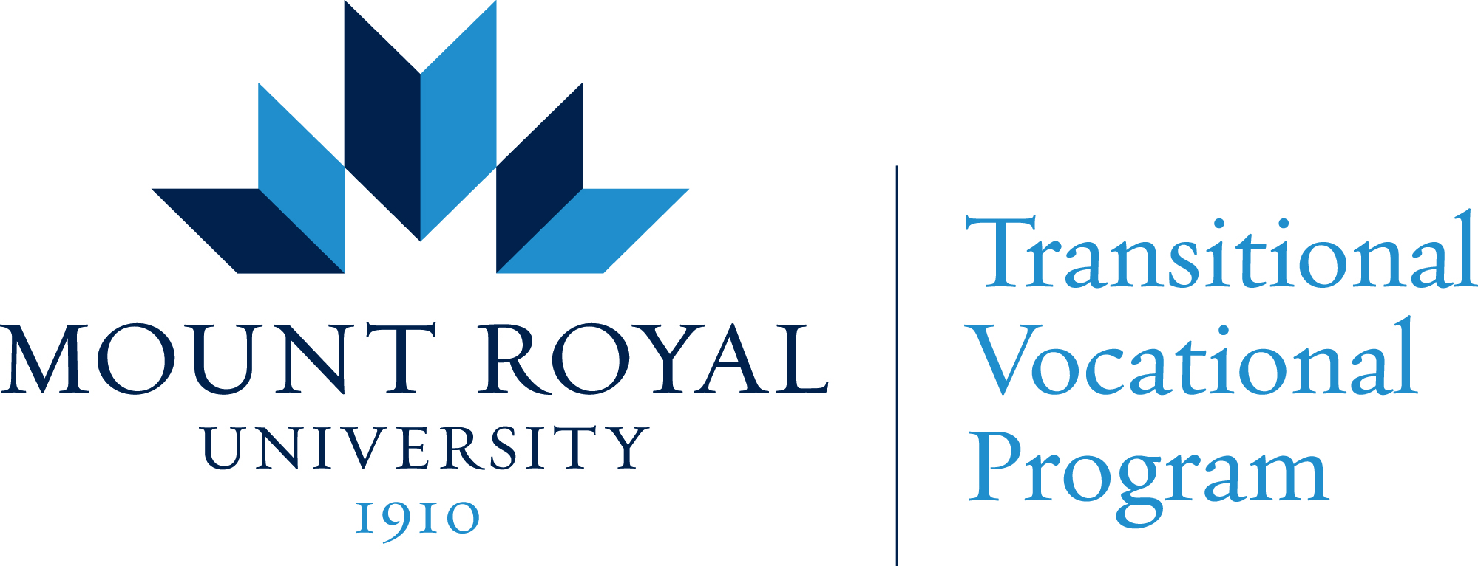

Pre-Employment Worksite Questionnaire

Mount Royal makes the health and safety of its students the highest priority. To aid us in determining the suitability of work practicum placements we ask that you complete the following questionnaire.

Attention:

1. Do you instruct work practicum students on your emergency procedures? YES/NO

2. Do you provide work term students with access to your company’s current
policy and procedures manual? YES/NO

3. Do you provide work practicum student with industry standard safety training? YES/NO

4. Do you require that work practicum students receive this training before being asked to
perform any unfamiliar tasks and are the students adequately supervised while
performing such tasks? YES/NO

5. Do you require that work practicum students have adequate supervision in the performance
of their everyday duties responsibilities and tasks? YES/NO
6. Can work practicum students decline participating in any activities or duties they feel unsafe
or vulnerable? YES/NO

7. Do you have Workers Compensation coverage for your employees? YES/NO

8. Do you carry liability insurance that covers personal injury, death and property damage
with a limit of not less than five (5) million dollars? (proof will be required) YES/NO

9. In the past 12 months has your department had any work related injuries or
incidents? YES/NO

10. Do you have an employment contract for paid employees? YES/NO

11. Have you implemented measures to protect staff from the risk of Covid 19 transmission? YES/NO
(detail specifics on back of form)

Work Practicum Student Name:

Company:

Authorized Company Representative (please print name):

Date: Signature:

Comments Section

Item #

Item #

Covid 19 specifics

Further information for employers available at:
https://www.alberta.ca/assets/documents/covid-19-workplace-guidance-for-business-owners.pdf

Employment Preparation Certificate Program Staff:

Date:

Employment Preparation Certificate Program Administrator:

Date:

Last Update:

